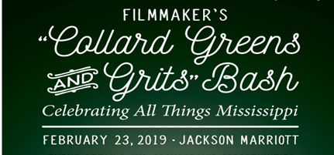

6:00 p.m. VIP Reception 7:00 p.m. Tastings & Awards

Sponsor Levels & Tickets

Presenting Sponsor = $5,000
Acknowledged as the sole Presenting Sponsor for the event
- Designated seat on the Judges Panel for chef competitions
- Name/logo featured as Presenting Sponsor on all marketing materials, including print, social media, and website
- 20 tickets to the VIP Reception and Bash main event
- Two reserved tables of 10 at the main event
- Live recognition during the main event
- Deliver brief opening remarks during the main event
- Assist in chef awards’ presentations
- Name/logo prominently featured on the cover of the commemorative program
- Full-page ad in the commemorative program
- Includes yearlong recognition and status as an annual NMHS Unlimited sponsor

VIP Champagne Reception Sponsor = $2,500
Acknowledged as the sole host of the VIP Champagne Reception, held from 6:00 until 7:00 p.m., prior to the Bash main event
- Deliver the champagne toast during the VIP Reception
- Name/logo displayed on VIP Reception swag bags
- 10 tickets to the VIP Reception and Bash main event
- 1 reserved table of 10 at the Bash main event
- Live recognition during the Bash main event
- Name/logo on marketing materials, including print, social media, and website
- Name/logo featured as a supporter in the commemorative program
- Full-page ad in the commemorative program
- Includes yearlong recognition and status as an annual NMHS Unlimited sponsor

International Marketplace Sponsor = $1,500
Honored as special host of the exclusive Silent Auction, which features unique and beautiful items from around the globe and locally
- Name/logo prominently displayed on signage at the silent auction
- 10 tickets to the VIP Reception and Bash main event
- 1 reserved table of 10 at the Bash main event
- Live recognition during the Bash main event
- Name/logo promoted through various marketing efforts
- Name/logo featured as a supporter in the commemorative program
- Includes yearlong recognition and status as an annual NMHS Unlimited sponsor

Sponsor Levels & Tickets Continued

Culinary Patron = $1,200
Enjoy a first-class experience as a valued sponsor
- 10 tickets to the VIP Reception and Bash main event
- 1 reserved table of 10 at the Bash main event
- Live recognition during the Bash main event
- Name/logo promoted through various marketing efforts
- Name/logo featured as a supporter in the commemorative program
- Includes yearlong recognition and status as an annual NMHS Unlimited sponsor

Additional Opportunities:
Full-page Ad in Commemorative Printed Program = $1,000
VIP Champagne Reception Tickets = $100 per person
General Admission Tickets to the Bash Main Event = $50 per person

BASH SPONSORSHIP FORM
Please complete and return form to blackhistoryplus@yahoo.com or P.O. Box 534, Jackson, MS 39174

SPONSORSHIP LEVEL:___________________________________________________________

METHOD OF PAYMENT: ( )CHECK ENCLOSED ( )PAYING ONLINE ( )PLEASE CONTACT ME

CONTACT NAME: ______

BUSINESS OR PERSONAL NAME:
* As you wish it to appear in promotion *

ADDRESS:

CITY: STATE: ZIP:

PHONE: ( ) EMAIL:

FOR MORE INFORMATION
Sponsorship/Ad Contact: Dr. Wilma E. Mosley Clopton at blackhistoryplus@yahoo.com or 601-259-7598
VIP Reception/General Admission Tickets Contact: Jimmy Garland at jimmygarland67@icloud.com
or 601-906-0100

NMHS Unlimited Film Productions is a 501(c)3 Mississippi-based production company specializing in documentaries about African American people in Mississippi and the way their actions changed the future for everyone. We sincerely appreciate your generous tax-deductible donation.
NMHS Unlimited Film Productions TAX-ID NUMBER 83-0512961.

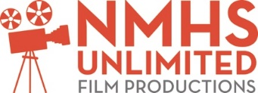
www.blackhistoryplus.com

